PRACTICAL - 2
1. Create aclient-server application using Named Pipes (FIFOs). The client sends messages and the server processes and responds to them. Analyze FIFO behavior when multiple clients communicate
For the server :
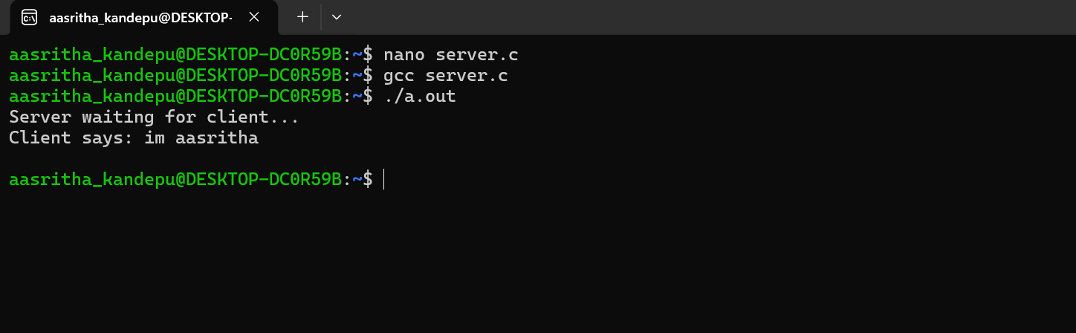
For the client :


